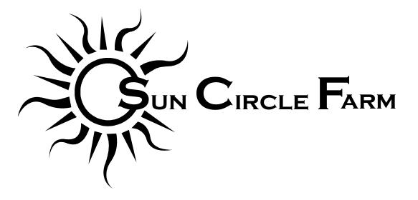
2018 CSA Commitment Form

Shareholder Contact Information
Name: _______________________________________________________
Address: _______________________________________________________
_______________________________________________________
Telephone: _______________________________________________________
E-mail: _______________________________________________________

CSA Share Option
_____ Full Share - $700 ($350 deposit)
_____ Small Share - $450 ($225 deposit)

Pick-Up Location
_____ Sun Circle Farm (Palmer)
_____ South Anchorage Farmer’s Market

By signing this form you agree to purchase a CSA share from Sun Circle Farm for the 2018 summer season. Our season will likely run from the week of June 6th or June 13th through the week of October 3rd, for a total of 17 weeks. Depending on the season, we will likely take “off” the first week of July, but will otherwise provide a weekly box of freshly harvested produce certified organically grown on Sun Circle Farm.
The second half of your payment is due by July 1st, but arrangements can be made for a more extended payment plan if you contact me before the season begins.
CSA pick-up will be on Wednesdays at Sun Circle Farm from 4-8pm or on Saturdays at the South Anchorage Farmer’s Market from 9am-2pm. Those picking up in Anchorage may have to make arrangements to pick up shares at the late end of the season, depending on how long we attend the South Anchorage Farmer’s Market.
By filling out this form and purchasing a share you are agreeing that there are no guarantees in agriculture and sharing any potential risks or shortcomings with us.
If you have any questions, please contact me at ancokell@gmail.com, call or text 707-3123, or see our website at www.suncirclefarm.com.
Thank you for supporting my farm!

Please make checks payable to Sun Circle Farm and mail them with your completed agreement to:
Sun Circle Farm
5605 Farm Loop Rd.
Palmer, AK 99645

Signature: ____________________________________________________________________

